M.A. Program
in Political Science

Welcome to the Master of Arts program in Political Science at Iowa State University. This handbook will provide you with information about our M.A. policies and procedures. Although many departmental regulations are specified within this handbook, you should be aware that there are additional requirements set forth by the Graduate College. These are outlined in the Graduate Student Handbook, which has information and guidelines to facilitate progress through the entire graduate program.
The handbook is on line at:
http://www.grad-college.iastate.edu/publications/gchandbook/homepage.html.
There is a one-page “Procedures for Earning a Master’s Degree at Iowa State University” that is an invaluable resource/checklist to follow as you work through your program. This is found in the Graduate Student Handbook and reprinted in this handbook.

As you begin your course of study there are bound to be questions or concerns you will have. We want to assure you that the faculty and staff will be available to assist you in any way we can. The program faculty and students welcome you and extend you our best wishes for success in your studies.

For further information about the M.A. Program contact:

Director of Graduate Education
549 Ross Hall
Iowa State University
Ames IA 50011
PHONE: (515) 294-1075
FAX: (515) 294-1003 mshelley@iastate.edu
WEB PAGE: http://www.pols.iastate.edu/

Table of Contents
Page

Guidelines for Pursuing an M.A. Degree 1
Admission/Application Requirements 1
Admission Requirements 1
Application Requirements 2
Application Deadlines 2
Class Registration Process 2
Canceling 3
Withdrawing 3
Degree Requirements 3
Graduate English Exam/English Proficiency Testing 3
SPEAK/TEACH (International TAs) 4
Program of Study Committee/Program of Study 4
Course Work 5
Thesis/Deadlines 5
Final Oral Examination 6
Registration for Classes 6
The M.A. Curriculum 7
M.A. Graduation Check List 9
Procedures for Earning a Master’s Degree 10
Financial Aid, Graduate Assistantships, and Scholarships 11
Graduate Assistantships 11
The Donald E. Boles Scholarship Award 11
Graduate Student Rights and Responsibilities (IMPORTANT) 11
Important Telephone Numbers and Contact Information 12

Guidelines for Pursuing a Master of Arts Degree

The department offers work for a Master of Arts degree (M.A.), with a major in political science, and minor for students in other departments. The Political Science department additionally serves as a home department for the Master of Science in Cyber Security (more in-depth information for the M.S. in Cyber Security is presented later in this handbook). Detailed requirements for all graduate degrees may be obtained from the department office or at the department’s web page: https://www.pols.iastate.edu/

The M.A. program is designed to enable its graduates to engage in research, enter public service or private industry, teach, or pursue further graduate study. Graduate students may also wish to work for certification for high school or junior college teaching.

A thesis is required for the M.A. degree. The department also has a joint Master of Arts/Juris Doctorate (M.A./J.D.) program with the Law School of Drake University. Detailed information for the M.A./J.D. can be found at the ISU Political Science webpage as well as the Drake Law School website. Students wishing to pursue this joint degree must submit separate applications to Drake University and Iowa State University and be accepted by both institutions.

M.A. graduates have a broad substantive understanding of the political process and the academic study of politics. They also have in-depth knowledge of one or more subfields in political science. Graduates are skilled at conducting research and preparing thorough research summaries. They are able to identify and address complex political questions, taking into account related ethical, legal, economic, and social issues.

Admission Requirements

The usual prerequisites for full admission to major graduate work in the M.A. program are completion of at least 12 credits in political science or related courses. It is highly recommended that students also have completed successfully one year of a single foreign language (equivalent to 8 semester hours), and a course in basic statistics (equivalent to Statistics 101). The M.A. degree requires completion of Statistics 587, which assumes successful completion of an introductory course. Full admission is rarely granted to students with less than a 3.00 (on a 4.00-point scale) undergraduate grade point average; otherwise, students may be offered restricted admission.

Students in other graduate programs may obtain a minor in political science by completing at least 9 graduate-level credits of political science courses, including one of the proseminars. Interested students should consult the Graduate College Handbook for additional information on graduate minors.

Application Requirements

- At least three letters of recommendation. Normally these would be from individuals who are competent to evaluate the applicant’s past academic performance and potential for graduate study.

- A 250-500 word essay. This essay should explain why the applicant wants to pursue the Master of Arts degree and what areas or topics in political science they would like to study in the program.

- Transcripts from previous undergraduate and graduate institutions.

- Application fee.

International Students: The department normally does not consider applicants whose native language is not English with a TOEFL score less than 85. Nonnative English speakers with undergraduate or graduate degrees from the United States are not required to take the TOEFL. Students whose first language is English or who have earned a degree from countries where the only official language is English are exempt from the language proficiency requirements.
(Please see this list).

Application Deadlines

The application deadline for fall admission is May 1 and the deadline for spring admission is October 1. The departmental financial aid deadline for students wishing to be considered for an assistantship is February 1. Assistantships are not generally awarded to students entering in the spring. The department does sometimes accept late applications for admission and financial aid, so contact the Director of Graduate Education if you are considering applying after the deadline.

Deadlines Department Financial Aid Deadline
Fall by May 1 Fall/Spring by February 1
Spring by October 1 (complete application: all requirements
Summer by March 1 fulfilled and in Political Science office)

Class Registration Process

The following information on registration policies and general “how to register” for classes can be found at this web address: https://catalog.iastate.edu/registration/.
You might want to check out the ISU home page (http://www.iastate.edu/ ) as well as the Graduate College home page (http://www.grad-college.iastate.edu/).

Canceling

Canceling your registration means you are dropping ALL your courses before the first day of the term. Other deadlines apply for some courses, such as half-term courses that do not begin at the start of the semester. Fort further information please see https://www.registrar.iastate.edu/students/registration/cancel-registration or call 515-294-1840.

Withdrawing

Withdrawing from the university means that you are dropping ALL your classes on or after the first day of the term. You must notify your advisor and your college when you decide to withdraw from the university. Contact your advisor to complete a “Request for Withdrawal” form. Your tuition adjustment is based on the date you begin the withdrawal process.

Degree Requirements

There are various requirements for each student progressing through the program. A brief description of these requirements, as well as the Procedures for Earning a Master’s Degree, is found in this section. The Procedures sheet is also listed on the Graduate College webpage, where each box has a link to help with any questions you may have. The Procedures page is a very important resource and serves as a road map through the degree program.

During the academic year, graduate students must be registered for a minimum of nine credits to be considered full-time students or five credits to be considered half-time students. During the summer term, graduate students must be registered for a minimum of five credits to be considered full-time students or three credits to be considered half-time students.

Master’s degree students are expected to complete the degree program within five years.

Graduate English Exam/English Proficiency Testing

Reading and writing in the English language are essential skills for succeeding in graduate school at Iowa State University and equally essential for future success in careers that require a graduate degree. An English examination is only required for students whose native language is not English.

Nonnative Speakers of English—Graduate students whose native language is not English and who did not graduate for a U.S. High School must take the English Placement Test at the beginning of their first semester of enrollment. This test is administered by the Department of English. It must be taken in addition to TOEFL (Test of English as a Foreign Language), which is taken as part of the admissions process. A student who does not pass this examination is assigned to one or more courses in the English 101 series. This course work must be completed during the first year of study.

Oral English Certification Test (International TAs)
All international graduate students who are offered or considered for a teaching assistantship are required to take the Oral English Certification Test (OECT). The OECT consists of 2 sections: the Oral Proficiency Interview (OPI) section and the TEACH teaching-simulation section. The OPI is rated by an interviewer and 2-3 other raters, and for TEACH “the class” usually consists of 2-3 raters and a proctor, including at least one ISU student. The raters individually assign a score for the overall comprehensibility and effectiveness of the spoken language and listening ability. The scores of OPI and TEACH are combined, and the result is reported to students and departments as one of four possible levels of certification:
- Fully certified (Level 1)
- Conditionally certified (Level 2)
- Certified with restrictions (Level 3)
- Not certified (Level 4)
Potential International TAs who demonstrate English proficiency on the TOEFL iBT, IELTS, or TSE are exempt from taking one or both sections of the OECT. Students in these four categories are each appointed to different teaching duties.

Program of Study Committee/Program of Study (POS)

The Director of Graduate Education (DOGE) will assist incoming students in outlining an academic program of study and in constituting a Program of Study Committee (POSC). A student’s POSC for the thesis option consists of the major professor and a minimum of two other committee members (one member must be from outside the major). The major professor, who must be a member of the graduate faculty in the student’s declared major, serves as chair of the POSC. The outside member(s) of the POSC provide relevant specialized knowledge or a different perspective helpful to the planning, execution, and reporting of research. If a graduate minor has been declared, a graduate faculty member from the minor program or interdepartmental minor must serve on the POSC. The major professor and the representative from the minor field may not be the same person. For students who select the creative component option, the POSC may consist of 1-3 faculty. It is important to consult with the DOGE prior to selecting your POSC member(s).

The student and the major professor develop the POS with the consultation and approval of the POSC. This agreement between the student and the Graduate College should be submitted as early as possible for approval. It is recommended that the committee be formed as early as the second semester of graduate study. At this time, the student needs to meet with the POSC to plan the remainder of courses in the selected degree program. In no case can the committee be formed later than the term before the final oral examination. POS forms are available through AccessPlus, as is a planning document that can be used to sketch out what the final POS will contain. Each student’s POS should be designed to correct deficiencies in academic preparation, allow study of subject matter that most interests the student, and avoid repetition in areas where the student is well prepared. The POSC assures that program requirements are met before signing the POS form. The Committee Appointment Form and the POS form are available through Access Plus.

The POS form is approved by the student, committee member(s), and the DOGE of the major, minor, or interdepartmental major/minor, as appropriate, before submitting it to the Graduate College through AccessPlus. There the POS is reviewed for adherence to the standards of the Graduate College and is submitted to the Dean of the Graduate College for approval.

A partial example of a completed POS form is shown below. A POS must be submitted to the Graduate College for approval listing all courses to be taken to fulfill the 30-credit requirement for the M.A. degree. This includes courses transferred, taken at ISU, and to be taken with additional information.

Course Work

Students must complete at least 30 semester credit hours. A minimum of 21 of these hours must be taken in the Department of Political Science. Six credits (two classes) of 400-level course work and three credits of thesis credit (Political Science 699) may be applied toward the 21-hour minimum. Please note that if you take dual-listed (400- and 500-level simultaneously) classes, you must be registered for 500-level credits for the course to count toward degree requirements.

II Planned Graduate Program
Line | University | * | Department Name | Course Number | Semester Credits | ** | Course Title | Grade | Year
1 | ISU |  | Pol S | 502 | 3 |  | Political Analysis & Research |  | F22
2 | ISU |  | Stat | 587 | 4 |  | Statistical Methods |  | S23
3 | ISU |  | Pol S | 580 | 3 |  | Ethics and Public Policy |  | S23
4 | ISU |  | Pol S | 508 | 3 |  | Policy Implementation |  | F23
5 | ISU |  | Pol S | 560 | 3 |  | American Political Institutions |  | F22
6 | ISU |  | Soc | 540 | 3 |  | Comparative Social Change |  | S23
7 | ISU |  | Pol S | 507 | 3 |  | Proseminar in Public Policy |  | F22
8 | ISU |  | Soc | 549 | 3 |  | Sociology of the Environment |  | F23
9 | ISU |  | Pol S | 590 | 2 |  | Special Topics |  | F23
10 | ISU |  | Pol S | 699 | 3 |  | Research/Thesis |  | S24
11 |  |  |  | Total Cr. | 30

Students are strongly encouraged to complete nine credit hours in graduate courses (10 credits including Statistics 587) outside the Department of Political Science that relate to their area of interest. These courses must be approved by the Director of Graduate Education or the student’s POS Committee, and any exceptions must be approved by the student’s POSC.

Thesis/Deadlines

All students are required to write a thesis or creative component. As a first step in this process, the POSC must approve a written thesis proposal. A thesis or creative component is considered complete when it is approved by the POSC and the Graduate College. Format instructions and deadlines for theses are found on the Graduate College home page at https://www.grad-college.iastate.edu/graduation/.

Final Oral Examination

After completion of all the requirements for the Master of Arts degree, the student will be administered a final oral examination (approximately two hours) by the POSC. The examination may cover all courses taken by the student and the material related to the thesis or creative component. There are several important deadlines for the final oral and for graduation. The Application for Graduation (Diploma Slip) must be turned in by the first Friday of the semester in which a student is planning to graduate (if not before). The Request for Final Oral form must be turned in three weeks prior to the actual date of exam. In addition, there is a Graduate College deadline each semester for the last date to take the final oral examination. Please see https://www.grad-college.iastate.edu/calendar/.

Registration for Classes

Admitted students should consult the DOGE or major professor prior to registering for classes. Students early in the program should give priority to core and methodology classes when making course selections. Advanced students should focus on connecting the concentration and thesis or creative component, in conjunction with the POSC. Courses related to the M.A. program and political science generally are listed on the Department’s web page at https://catalog.iastate.edu/azcourses/pol_s/#graduateundergraduatecourses. Detailed information about the availability of all classes for a specific semester is available at https://classes.iastate.edu/.

Registration can be accomplished online through the Access Plus system which requires an ISU ID and password. Deadlines and other related information are provided in the Academic Calendars (https://www.registrar.iastate.edu/calendar).

An alternate registration procedure is a walk-through system to Room 10, Enrollment Services Center. Many students take some of their courses off-campus. Registration for off-campus classes can be done through the Registrar’s Office at https://www.distance.iastate.edu/apply-and-enroll/.

Non-admitted students may register for graduate classes as well (through the non-degree program). However, students who are not admitted should be aware that a strict limit of 9 credits may be transferred into the POS after acceptance into the M.A. program. Credits transferred from another institution must be approved by the student’s POSC. (See the Graduate College Handbook for more information on transfer credits.)

The M.A. Curriculum Requirements (30 credits)

Required Courses:

I. Concentration Area Required Courses | (6 cr)
II. Concentration Area Elective | (3 cr)
III. Pol S 502 Political Analysis and Research | (3 cr)
IV. Statistics 587 (formerly 401) (Strongly recommended)  OR | (4 cr)
2 years of a single foreign language | (16-20 cr)
V. Thesis | (3 cr)

Concentration Areas:

The M.A. program features three concentration areas: American Politics, Global Politics, and Public Policy. In each concentration area there will be two required classes offered alternate years, normally in the fall. There will also be elective courses, most of them offered alternate years. Deviations from the curricular requirements such as counting courses not listed below as concentration area electives require approval from the DOGE or the POSC. Students admitted prior to 2016 may use the previous requirements.

Required Courses in each concentration:
American Politics: 560 American Political Institutions and 525 Mass Political Behavior.
Global Politics: 504 Proseminar in International Politics, 505 Proseminar in Comparative Politics.
Public Policy: 507 Proseminar in Public Policy, Policy Implementation 508X

Elective Courses
American Politics: 510, 513, 587, 610 A
Global Politics: 544, 552, 581, 610 D, 610 E
Public Policy: 513, 515, 516, 534, 535, 542, 544, 571, 572, 574, 575, 577, 580, 582, 587, 610 G.

Required Course Distribution: 30 credits are required for the degree, of which 21 credits must be from Political Science. Of the 21, up to 9 credits may be from 400-level classes in the Political Science Department. Note that the total number of credits from classes numbered below the 500 level that may be used on the POS is 9 (eligible courses in Political Science must be 400-level and courses in other departments must be at least 300-level). The required courses above count toward this distribution based on the department in which the class is taken. So, your POS course distribution must include at least 12 500-level credits in Political Science. You also may take as many as 9 400-level credits in Political Science or split those 400-level credits across departments. If you choose to count a 300-level course on the POS it must be from another department. Please be aware that if you choose to take a course that is numbered at both 400 and 500 levels you could not count those credits as 400-level if you have already used up your undergraduate distribution limit of 9 credit hours. It is important to understand that credits for foreign language (e.g., German 101, 102, 201, and 202; Chinese 101, 102, 201, and 202) are not acceptable for graduate credit, so do not count toward the 30 credits required to receive the M.A. The 4 credits for Statistics 587 do count as graduate credit, and are applied toward the 30 credits required for graduation. Students whose first language is not English normally will not be expected to take two years of another foreign language, but in such cases are required to take Statistics 587. Note that 300-level courses in other departments are eligible for the POS if they are not cross-listed with Political Science. Please see Section 5.1.2 of the Graduate College Handbook (https://www.grad-college.iastate.edu/handbook/) for further information. Also, see the following page for the course distribution checklist.
Other Requirements Graduate English Placement Test.
(required for all international graduate students—to be taken before completion of 12 credits. International students may be required to take additional courses in English as a Second Language depending upon their scores.)

Master of Arts in Political Science

Graduation Checklist

Required Courses Checklist (write course department and number in blank)
________ | Concentration Required Course 1 | (3 cr)
________ | Concentration Required Course 2 | (3 cr)
________ | Concentration Elective | (3 cr)
________ | Pol S 502 Political Analysis and Research | (3 cr)
________ | Statistics 587 (401) (or 16-20 credits of a single foreign language) | (4 cr)
________ | Thesis  Course Distribution Worksheet | (3 cr)

In this column, list at least 21 credits taken in the Department of Political Science. Classes listed above may be repeated on this list. Only two 590 courses may be taken except by permission of the Director of Graduate Education.

Course Credits

_______________ ______
_______________ ______
_______________ ______
_______________ ______
_______________ ______
_______________ ______
_______________ ______
_______________ ______

Total _______

In this column, list at least 9 additional credits. These may be taken outside of political science and should be relevant to your field of study. Students who use a language in place of Stat 587 (401) will need additional credits in this section.

Course Credits

_______________ ______
_______________ ______
_______________ ______
_______________ ______
_______________ ______
_______________ ______
_______________ ______
_______________ ______

Total _______

Other Requirements
_______ No more than 9 credits below the 500-level used to reach total of 30
_______ Graduate English Exam (required for all international graduate students, to be taken before complete of 12 course credits)
_______ Meet with DOGE and set up POS Committee
_______ Meet with POS Committee
_______ Submit written thesis proposal to POS Committee
_______ Final Oral Exam of Thesis or Creative Component

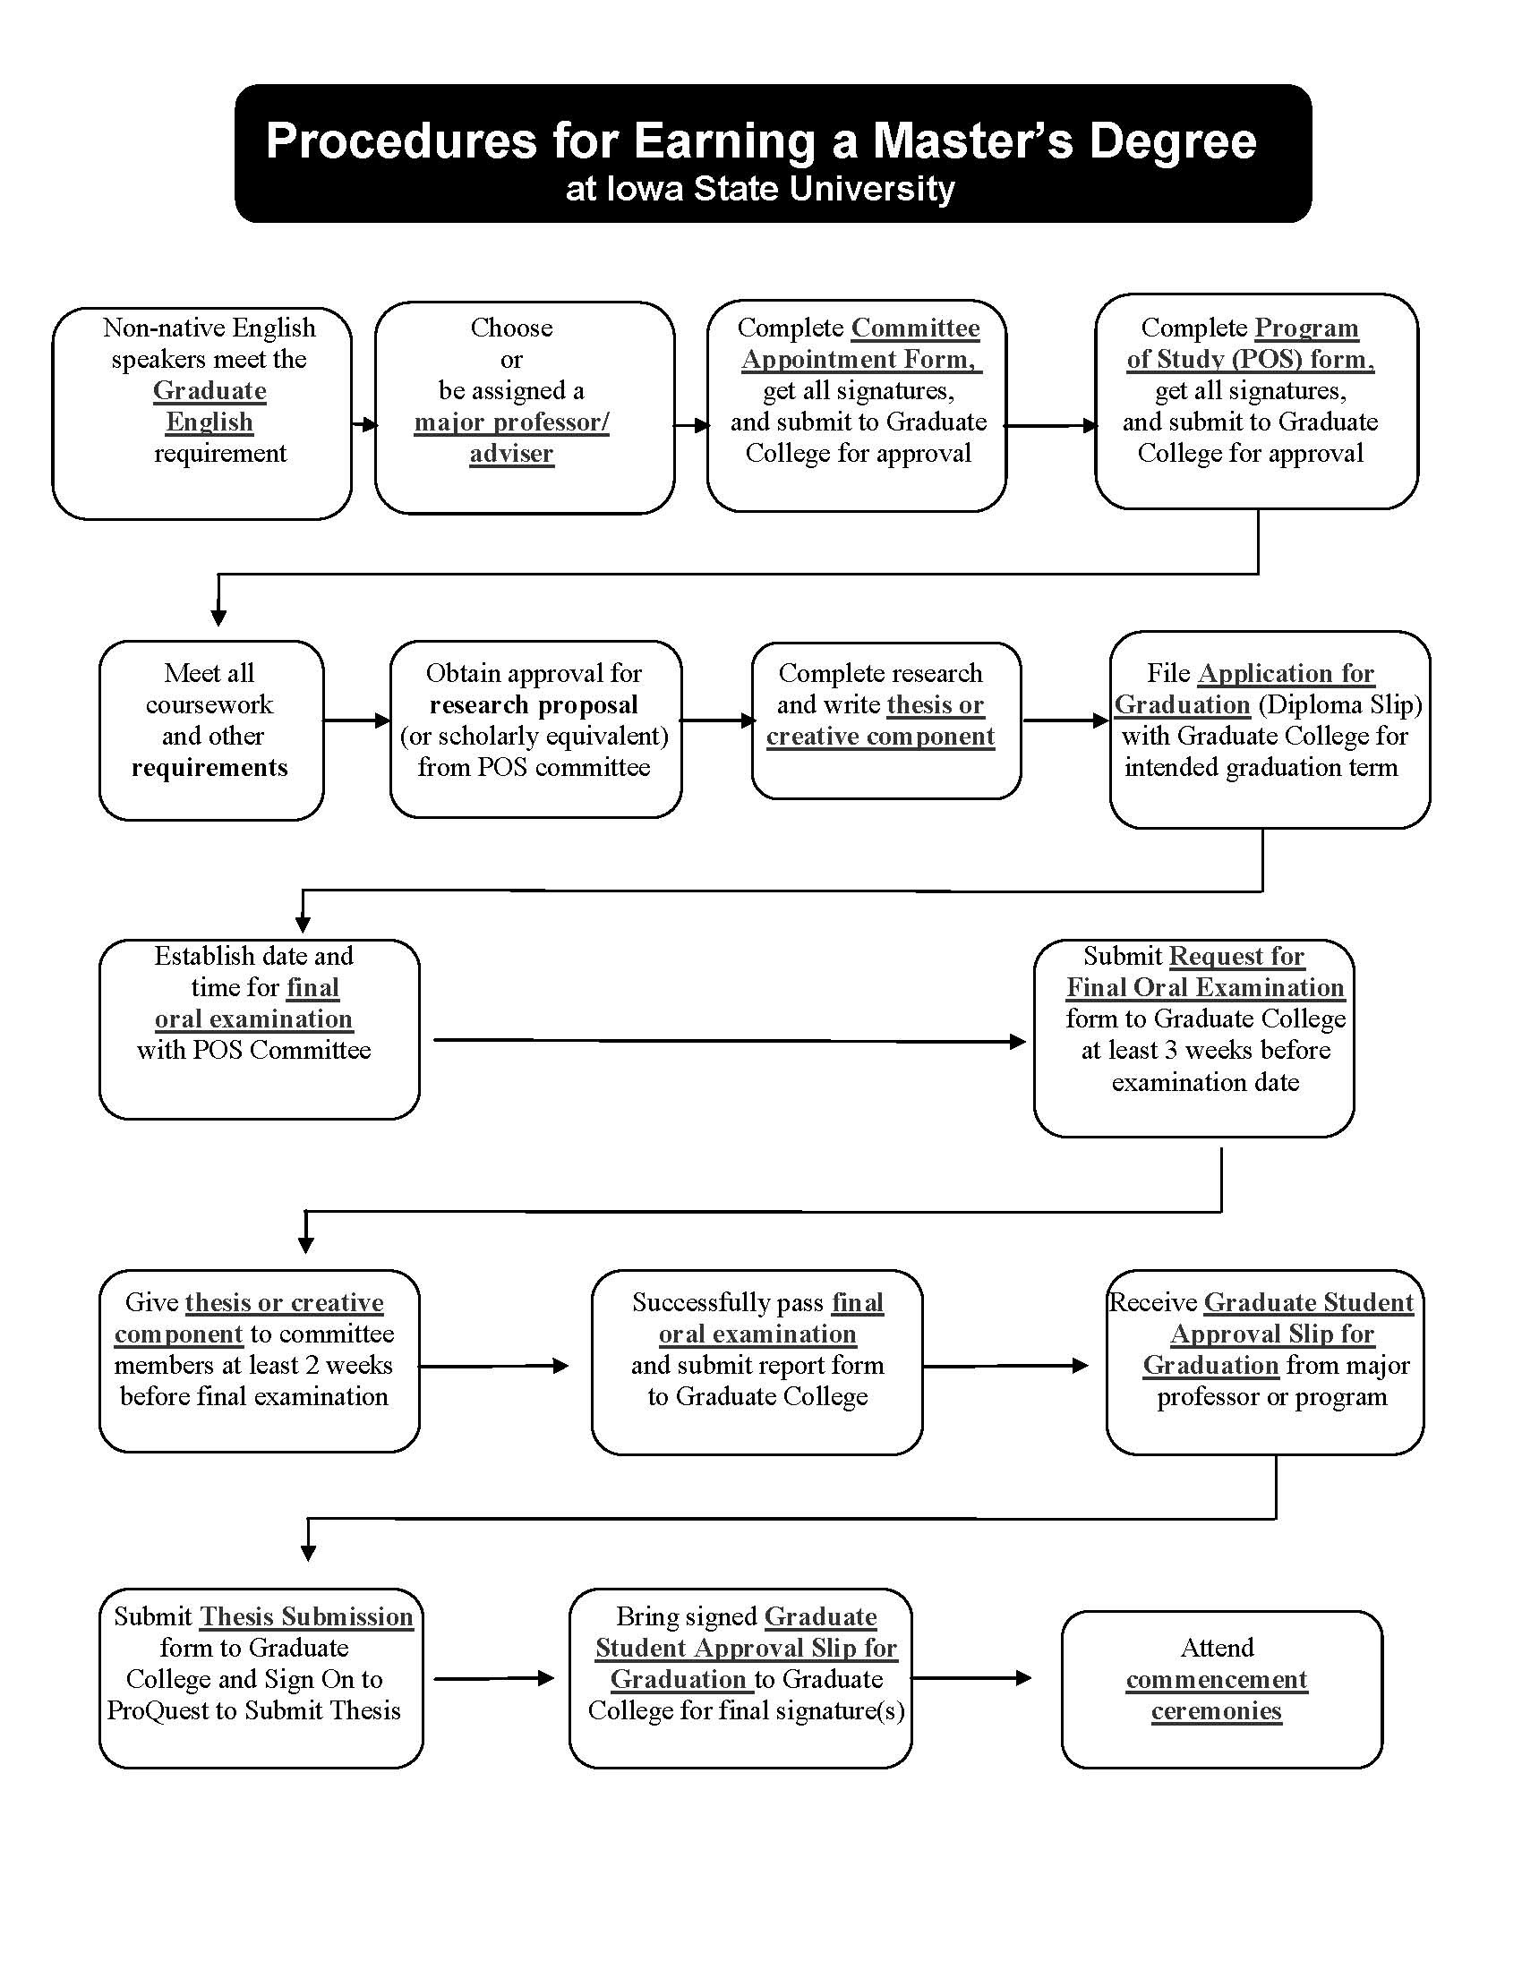

Financial Aid, Graduate Assistantships, and Scholarships

Some students may be eligible for financial aid for all degree programs discussed in this handbook. Financial aid applications are available in the Student Financial Aid Office, Room 0210, Beardshear Hall. 515-294-2223. Departmental deadline for completed financial aid/graduate applications is February 1 for consideration for the next academic year.

Graduate Assistantships

Two types of Graduate Assistantships are available: Teaching Assistantships (TA) and Research Assistantships (RA). These positions are limited so it is important that you apply for an assistantship early in the year. These assistantships provide a unique opportunity for students to gain valuable experience while providing financial support through the school year. The assistantships also include a medical insurance package through Blue Cross–Blue Shield. A dental plan is also available for an additional fee. Students may apply for assistantships by submitting completed program application with financial aid materials by February 1 for consideration for the next academic year.

Graduate Students Awards

Through its generous alumni donors, the Department of Political Science provides a number of competitive awards. These include:
- Whitaker-Lindgren Graduate Scholars in Political Science
- Dr. Yong S. Lee Excellence in Public Management Scholarship
- Philip R. Baumann Graduate Scholarship
- James A. Socknat Memorial Scholarship
- Dwight Ink Graduate Student Award
- Early Achievement in Graduate Research Award
- Iowa State University Teaching Excellence Award
- Iowa State University Research Excellence Award
The application deadline is March 1. Dollar amounts of the awards vary.

Graduate Student Rights and Responsibilities (IMPORTANT)

All student rights and responsibilities, information dealing with academic probation, grievance procedures, etc. can be found in the Graduate College Handbook, Chapter 9: Rights and Responsibilities. Students must maintain a GPA of 3.00 or will be placed on academic probation, which can affect an assistantship. The Political Science Department graduate program follows all rules and procedures as set forth by the Graduate College. Please be sure to review this information.

Important Telephone Numbers and Contact Information
Iowa State University

Iowa State University web site: Most university information can be obtained at this site. Includes an index for easy tracking of information, student information, etc.: http://www.iastate.edu

Engineering Online—LAS Online: https://www.elo.iastate.edu/ Main office:
elo@iastate.edu Tech Support: elotech@iastate.edu Phone: (515)294-7470; Iowa State University Online and Distance Learning: https://www.distance.iastate.edu/

Drake University Law School, Drake University, Des Moines, IA 50311 Joint degree in Political Science: M.A./J.D.
Website: https://www.drake.edu/law/future/academics/joint-degrees/
Admissions: (515) 271-2782

Graduate College, Room 1137 Pearson Hall (515) 294-4531
Web site: www.grad-college.iastate.edu
All graduate applications, forms, handbooks and general information can be found at the Graduate College website. The Graduate College has information on departmental deadlines, financial assistance, GRE requirements, etc., as well as a directory of graduate programs.

International Students and Scholars, 3248 Memorial Union (515)-294-1120
International students should check out the web site for information on visas and other required procedures: https://isso.dso.iastate.edu/

Political Science Department, 503 Ross Hall (515) 294-7256
In-depth information on the Political Science graduate programs can be found at the departmental website: https://www.pols.iastate.edu/academics/graduate/

Office of Admissions, 100 Enrollment Services Center. 1-800-262-3810 (in U.S.) or (515)
294-5836 Website: http://www.admissions.iastate.edu/graduate/index.php
Admissions questions can be sent by e-mail to: admissions@iastate.edu

Office of Student Financial Aid, 0210 Beardshear Hall (515)-294-2223
Website: http://www.financialaid.iastate.edu/ email: financialaid@iastate.edu

